Assignment: JavaScript Exercise, Part 3
For this assignment, you will be creating a To Do List. You won't need to create a separate JavaScript file, but you can if you like. You'll need a text box, three buttons, and instructions for the user. You do not need to follow the example in page design in terms of button placement or size or color, feel free to be creative.

Assignment Details:
1. Assignment Instructions
- Create a new folder under your local csd-340 folder (repository) and name it module-11
- Create an HTML file and name the file LastName_Mod11_2.html
- Add a link in the index.html file to the new LastName_Mod11.2 HTML file
  - Hint: Refer back to assignment 4.2 if you are confused on what this item is referencing
- Contents of LastName_Mod11_2.html
  - Make sure HTML page title says “CSD 340 Web Development with HTML and CSS”
  - Rename the h1 text value to “Assignment 11.2: JavaScript - Part 3”
  - Create a text box and three buttons. One button should be labeled "Add", one button should be labled "Delete Last Entry", last button should be labeled "Display".
  - Create a javascript section. Add a function for adding an element to an array, a function for deleting an element in an array, and a function for displaying the contents of the array.
    - When the Add button is clicked, the contents of the text box should be added to an array using a function. The user should also see an alert pop up that lets them see what was added where.
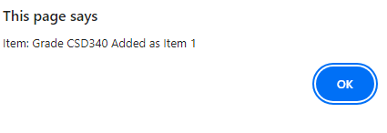
    - When the Delete Last Entry button is clicked, the last element of the array should be deleted using a function. You can manipulate the array.length or use pop(). Optional: Allow user to select which item to be deleted.
    - When the Display button is clicked, the contents of the array should be displayed, using a function, in order starting with 1. For example, the first item should be displayed as '1.' not 0.
2. Browser Output Example
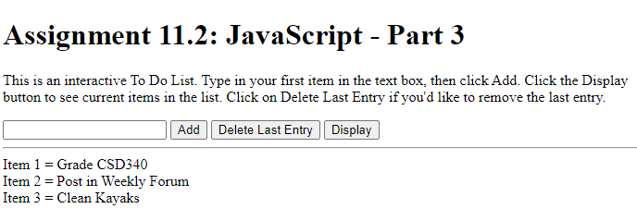
3. GitHub
- Stage, commit, and push your work to GitHub.
  - Click on the following link for instructions: GitHub Stage, Commit, and Push.pdf
4. Deliverables
- URL to your repositories GitHub pages website
- module-11 directory packaged as a .zip file

Assignment Requirements and Grading:
- This assignment is due by Sunday, 11:59 p.m., CST.
- Submit your assignment by clicking on the Assignment Link above, then scroll down to the Attach Files section and click on Browse My Computer. Select your assignment file, add any links or comments as appropriate, and then click on Submit.
- To view the grading rubric for this assignment, click on the following link: Programming Grading Rubric.
(50 points)

